Milestone 4

DSC550 Model Building and Evaluation

As I imposed my thoughts in milestone 1 towards going with Customer Churn analysis in any industry related to sales, purchase, interests and fall offs. So, I am taking in further in detail and start my Milestone 3 that will include details as below –

Introduction
A customer churn analysis model is a tool that businesses use to predict and understand why customers stop using their products or services. It helps identify at-risk customers, allowing businesses to proactively intervene and improve retention strategies. These models utilize various data points and machine learning techniques to assess the likelihood of a customer churning

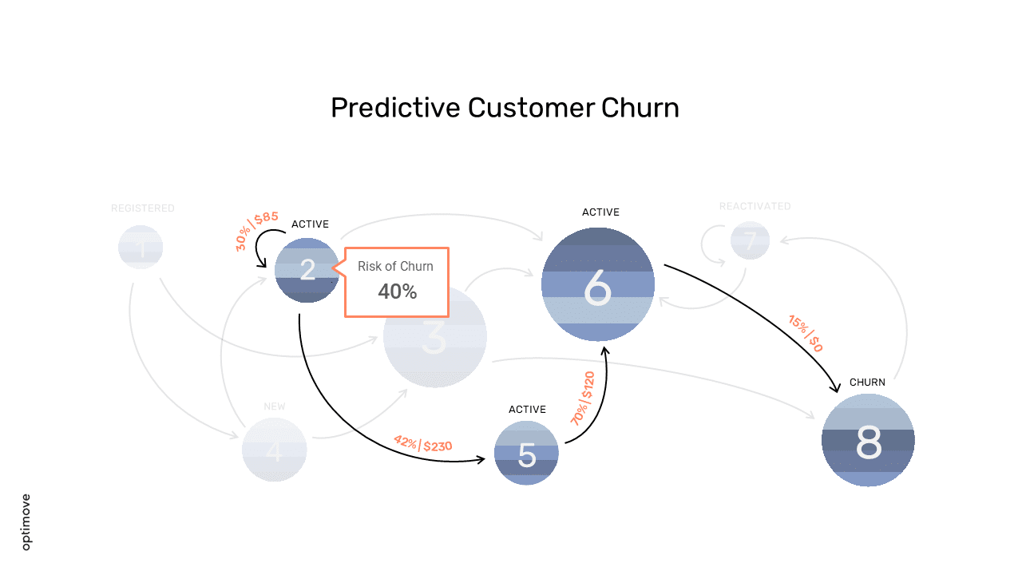

What is Customer Churn?
Customer churn, also known as customer attrition, refers to the rate at which customers stop doing business with a company. It's a critical metric for subscription-based businesses and those with recurring revenue models
Why is Churn Analysis Important?
- Reduced Revenue: High churn rates directly impact revenue and profitability.
- Increased Acquisition Costs: It's generally more expensive to acquire new customers than to retain existing ones.
- Negative Impact on Brand Reputation: Churn can signal customer dissatisfaction and negatively affect brand perception.
- Lost Opportunities: Churning customers may have been valuable sources of referrals or future business.

Types of Churn Models:
- Predictive Churn Models: These models use historical data to predict the probability of a customer churning in the future.

- Descriptive Churn Models: These models focus on understanding past churn behavior to identify patterns and key drivers of churn

Key Components of a Churn Analysis Model:
Following are the steps taken care in model programming and relate it with this document details-

- Data Collection: Gathering relevant customer data, including demographics, purchase history, usage patterns, and customer support interactions.
- Data Cleaning and Preparation: Ensuring data quality and consistency for accurate model training.
- Feature Engineering: Selecting and transforming relevant variables (features) from the data that can be used to predict churn.
- Model Selection: Choosing appropriate machine learning algorithms (e.g., logistic regression, decision trees, random forests, neural networks) to predict churn.
- Model Training and Evaluation: Training the model on historical data and evaluating its performance using metrics like accuracy, precision, and recall.
- Model Deployment: Integrating the churn model into business processes to identify at-risk customers and trigger targeted interventions.

Objectives
I will explore the data and try to answer some questions like:
- What's the % of Churn Customers and customers that keep in with the active services?

- Are there any patterns in Churn Customers based on the gender?

- Is there any patterns/preference in Churn Customers based on the type of service provided?

- What's the most profitable service types?

- Which features and services are most profitable?

- Many more questions that will arise during the analysis

Examples of Predictive Models:
There are following models can be used for modeling and I will try to accommodate for Milestone 3.
- Logistic Regression: Predicts the probability of churn based on a set of independent variables.
- Decision Trees: Creates a tree-like structure to classify customers based on a series of rules.
- Random Forests: An ensemble method that combines multiple decision trees to improve predictive accuracy.
- Gradient Boosting: Gradient Boosting is an ensemble learning method used for classification and regression tasks. It is a boosting algorithm which combine multiple weak learner to create a strong predictive model. It works by sequentially training models where each new model tries to correct the errors made by its predecessor.by sequentially training models where each new model tries to correct the errors made by its predecessor.
Churn Prediction Models in Action:
Following are the metrics can be considered while doing the model prediction for customer churn analysis.

- Churn Risk Score: Assigning a score to each customer indicating their likelihood of churning.
- Churn Segmentation: Grouping customers based on their churn risk to prioritize retention efforts.
- Targeted Interventions: Implementing specific actions, such as personalized offers or proactive support, to address the needs of at-risk customers.

Conclusion
A customer churn system is based on machine learning methods, a decision tree classifier, and a random forest algorithm. Here, prior to and after up sampling and KNN, both techniques are applied to the system. Decision tree classifier models initially produced poor results on an unbalanced dataset that did not take ultimate accuracy into account when matrices were used to evaluate the model. In comparison to a decision tree classifier, a random forest classifier produces better results. With an overall accuracy of 99 %, the random forest classifier predicts churn. The classifier matrix has a precision of 99 %, a recall factor of 99 %, and an accuracy of 99.09 %. System comprises churn prevention that is based on survival analysis using Cox Proportional Hazard model and retention plans. Survival curve is used for the selected customers plays an important role in customer churn prediction. In the telecom sector, it appears obvious that lowering customer effort is a method to boost customer retention. This churn prevention system may be made more complex and sophisticated in the future to provide better and more precise recommendations. More advanced algorithms such as deep learning recurrent neural networks that help to identify nonlinear complex relationships between data variables which may be applicable in future study to estimate survival likelihood. Moreover, customer churn prediction in the telecommunication sector is possible a rough set approach and data certainty [24] in future.

